Hospice Niagara Office 365 Web Access Instructions
Updated February 24, 2015

Following our recent migration to a new, expanded organizational email service, we are happy to announce that we are able to provide all staff with their own personalized Hospice Niagara email address. This will allow for more efficient and cost-saving communication of organizational information without having to fill up your personal email boxes, or print and mail letters. Your email address is unique to you, and your password is confidential. We ask that you do not share your password with anyone. You may opt to forward your Hospice Niagara emails to a personal email address that you possibly check on a more frequent basis. Instructions on forwarding emails can be found on the next page.
How to access your Hospice Niagara Email via Web Access:
Your email can be accessed on any device with internet via this link: https://portal.microsoftonline.com
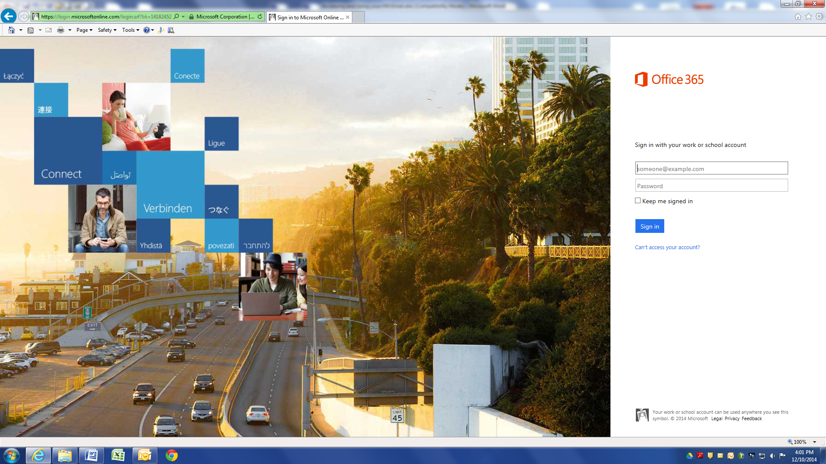
If you forget this link, type “Office Online Services” or “Office 365” into a search engine (such as Google) and one of the first search results will be “Sign in to Microsoft Online Services.” This is your login page.

Enter your email address and password. The information is listed here:
Name: _____________________________
Email Address: _____________________________
Password: _____________________________
Upon logging in, you will see the options below. Click on Outlook to access your email, People to access all Hospice Niagara staff contacts and any contacts you have added, Calendar to view your Hospice Niagara calendar and Tasks for any job tasks that you have added for yourself.
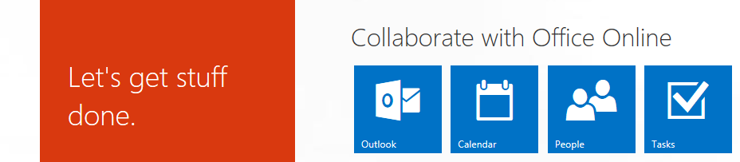

The Calendar is a really useful tool. With it, you will be able to see and keep track of Hospice Niagara related events to which you have been invited. You may accept or decline invitations and have all of the information on hand.

Email Forwarding:
If you would prefer to forward your emails that are sent to your Hospice Niagara account to another personal email account, here are the instructions:
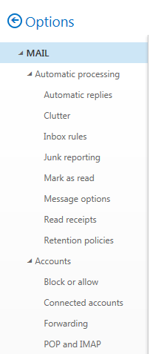
- In the top right corner, press the “Cogwheel” button that will take you to Settings, and then choose OPTIONS:
- Click on the > arrow beside the word MAIL, which will open up a drop down menu.
- Under the ACCOUNTS heading, select FORWARDING
- Select the radio button beside “Start Forwarding” and enter the email address to
which you would like to forward your emails.

- Selecting the box below that states “Keep a copy of forwarded messages” will keep
emails in your Office 365 email so that you can refer to them if you log in.

Signing Out:
Sign out of Office 365 by clicking on the Person icon at the top right of the page.
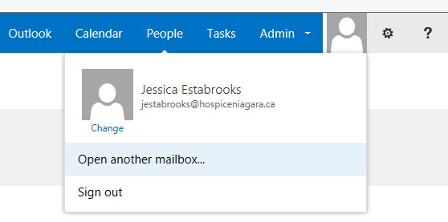

If you have any questions, contact Jessica Estabrooks at jestabrooks@hospiceniagara.ca or any of the Admin team while you are at The Stabler Centre.

